For this assignment, I created a database called books_assignment and a table called books. I used the import wizard in MYSQL Workbench to import all 50 books.

The table has five columns: bookid (primary key), title, category, and price. I ran a SELECT query to check the data. The screenshot below shows the books and the 50 rows returned.

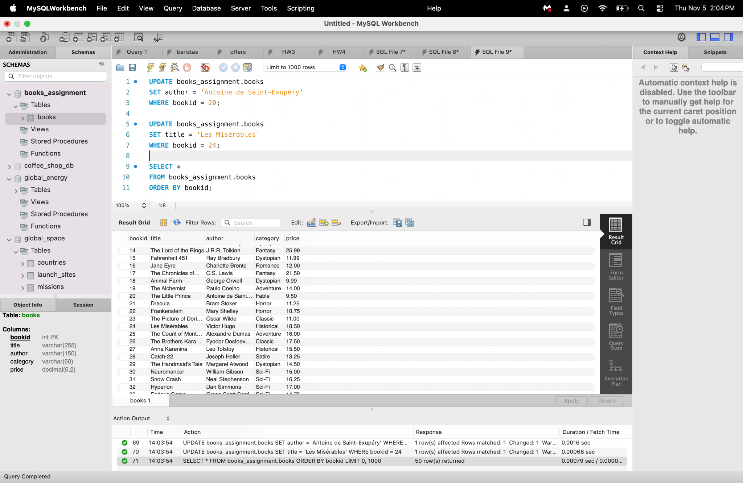

1
const express = require("express");

2
const pool = require("./mysql");

3

4
const app = express();

5
const PORT = 3000;

6

7
app.set("json spaces", 2);

8

9
// Encode database values safely for HTML output.

10
function escapeHtml(value) {

11
return String(value).replace(/[&<>"']/g, (character) => ({

12
"&": "&amp;",

13
"<": "&lt;",

14
">": "&gt;",

15
'"': "&quot;",

16
"'": "&#39;"

17
})[character]);

18
}

19

20
app.get("/", async (req, res) => {

21
const { category, author, format = "json" } = req.query;

22

23
// Each parameter must contain a single text value.

24
for (const value of [category, author, format]) {

25
if (value !== undefined && typeof value !== "string") {

26
return res.status(400).json({

27
error: "Parameters must contain single text values."

28
});

29
}

30
}

31

32
if (format !== "json" && format !== "text") {

33
return res.status(400).json({

34
error: "Use format=json or format=text."

35
});

36
}

37

38
let sql = `

39
SELECT bookid, title, author, category, price

40
FROM books

41
`;

42

43
const conditions = [];

44
const values = [];

45

46
if (category !== undefined) {

47
conditions.push("category = ?");

48
values.push(category);

49
}

50

51
if (author !== undefined) {

52
conditions.push("author = ?");

53
values.push(author);

54
}

55

56
if (conditions.length > 0) {

57
sql += " WHERE " + conditions.join(" AND ");

58
}

59

60
sql += " ORDER BY bookid";
61

62
try {

63
// Placeholders keep user input separate from SQL commands.

64
const [books] = await pool.execute(sql, values);

65

66
if (format === "text") {

67
const items = books.map((book) => `

68
<li>

69
<strong>${escapeHtml(book.title)}</strong>

70
— ${escapeHtml(book.author)}

71
| ${escapeHtml(book.category)}

72
| $${Number(book.price).toFixed(2)}

73
| Book ID: ${book.bookid}

74
</li>

75
`).join("");

76

77
return res.type("html").send(`

78
<!DOCTYPE html>

79
<html lang="en">

80
<head>

81
<meta charset="UTF-8">

82
<title>Book Search Results</title>

83
</head>

84
<body>

85
<h1>Book Search Results</h1>

86
<p>${books.length} book(s) found.</p>

87
${books.length > 0

88
? `<ul>${items}</ul>`

89
: "<p>No matching books found.</p>"}

90
</body>

91
</html>

92
`);

93
}

94

95
return res.json(books);

96
} catch (error) {

97
console.error("Database query failed:", error.message);

98

99
if (format === "text") {

100
return res.status(500).type("html").send(

101
"<h1>Database error</h1><p>Unable to retrieve books.</p>"

102
);

103
}

104

105
return res.status(500).json({

106
error: "Unable to retrieve books."

107
});

108
}

109
});

110

111
app.listen(PORT, () => {

112
console.log(`Server running at http://localhost:${PORT}`);

113
});

Example 1 - Author search (default JSON):
http://localhost:3000/?author=George%20Orwell
Result: 1984 and Animal Farm by Geroge Orwell
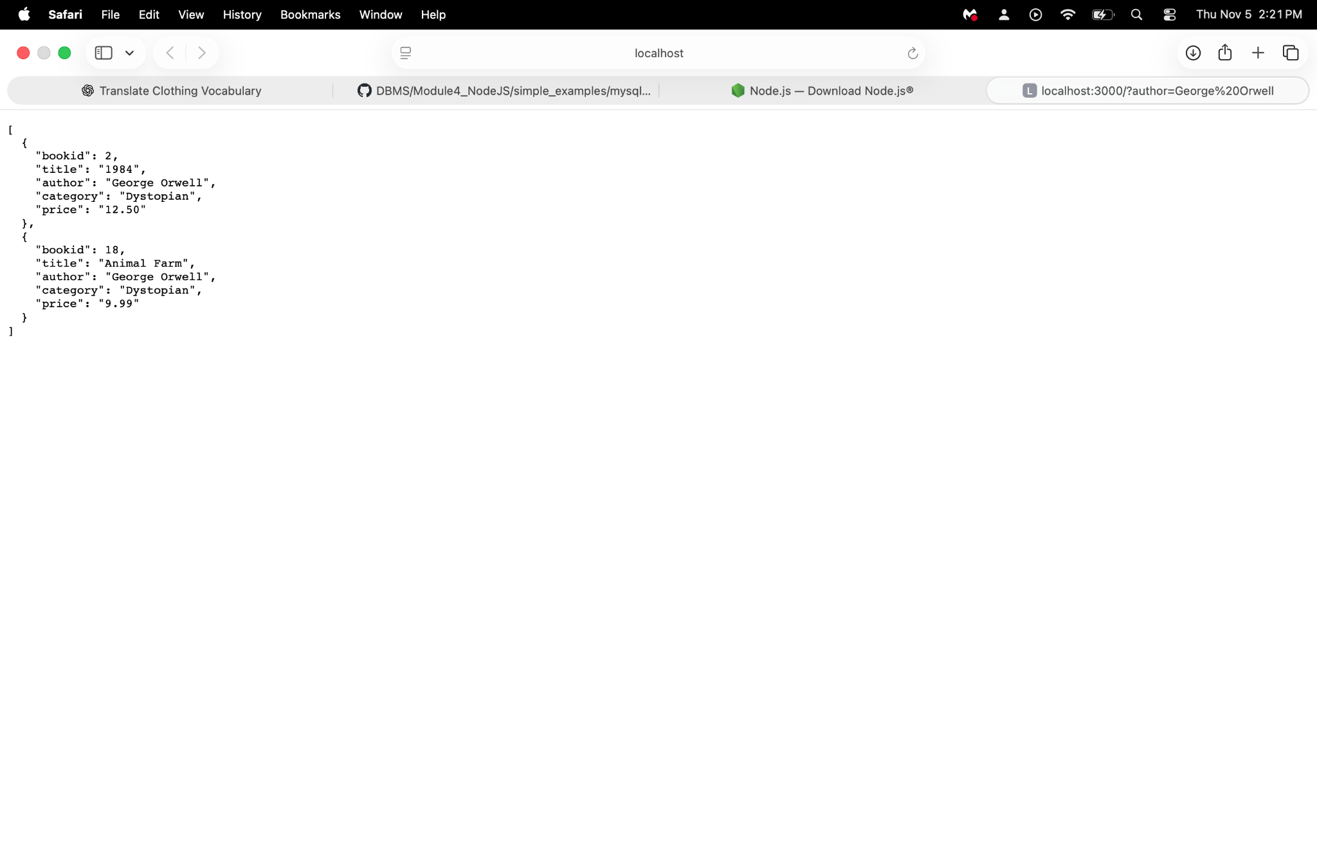

Example 2 Category Search(explicit JSON)
http://localhost:3000/?category=Horror&format=json
Result: Dracula by Bram Stoker and Frankenstein by Mary Shelley
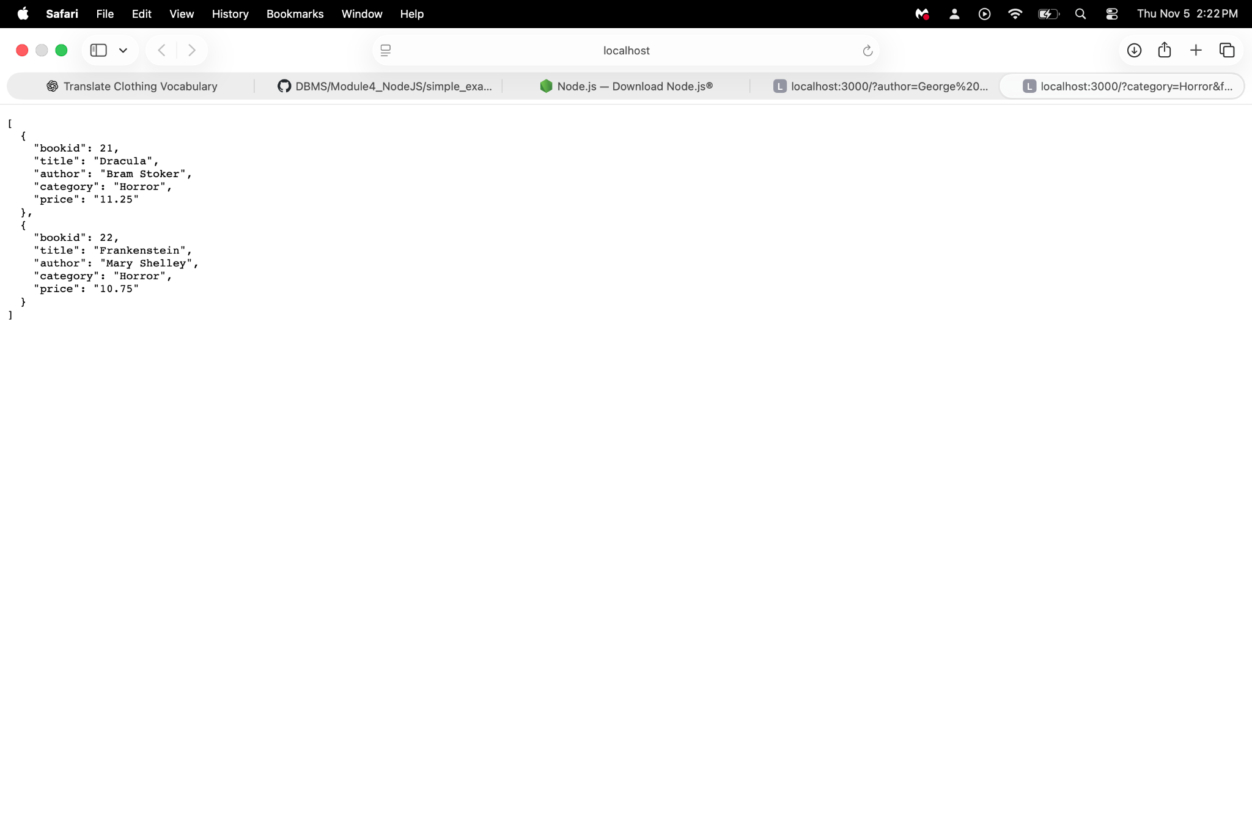
http://localhost:3000/?category=Horror&format=text

The text option returns readable HTML listing the two matching books with their authors, categories,

prices, and book IDs.
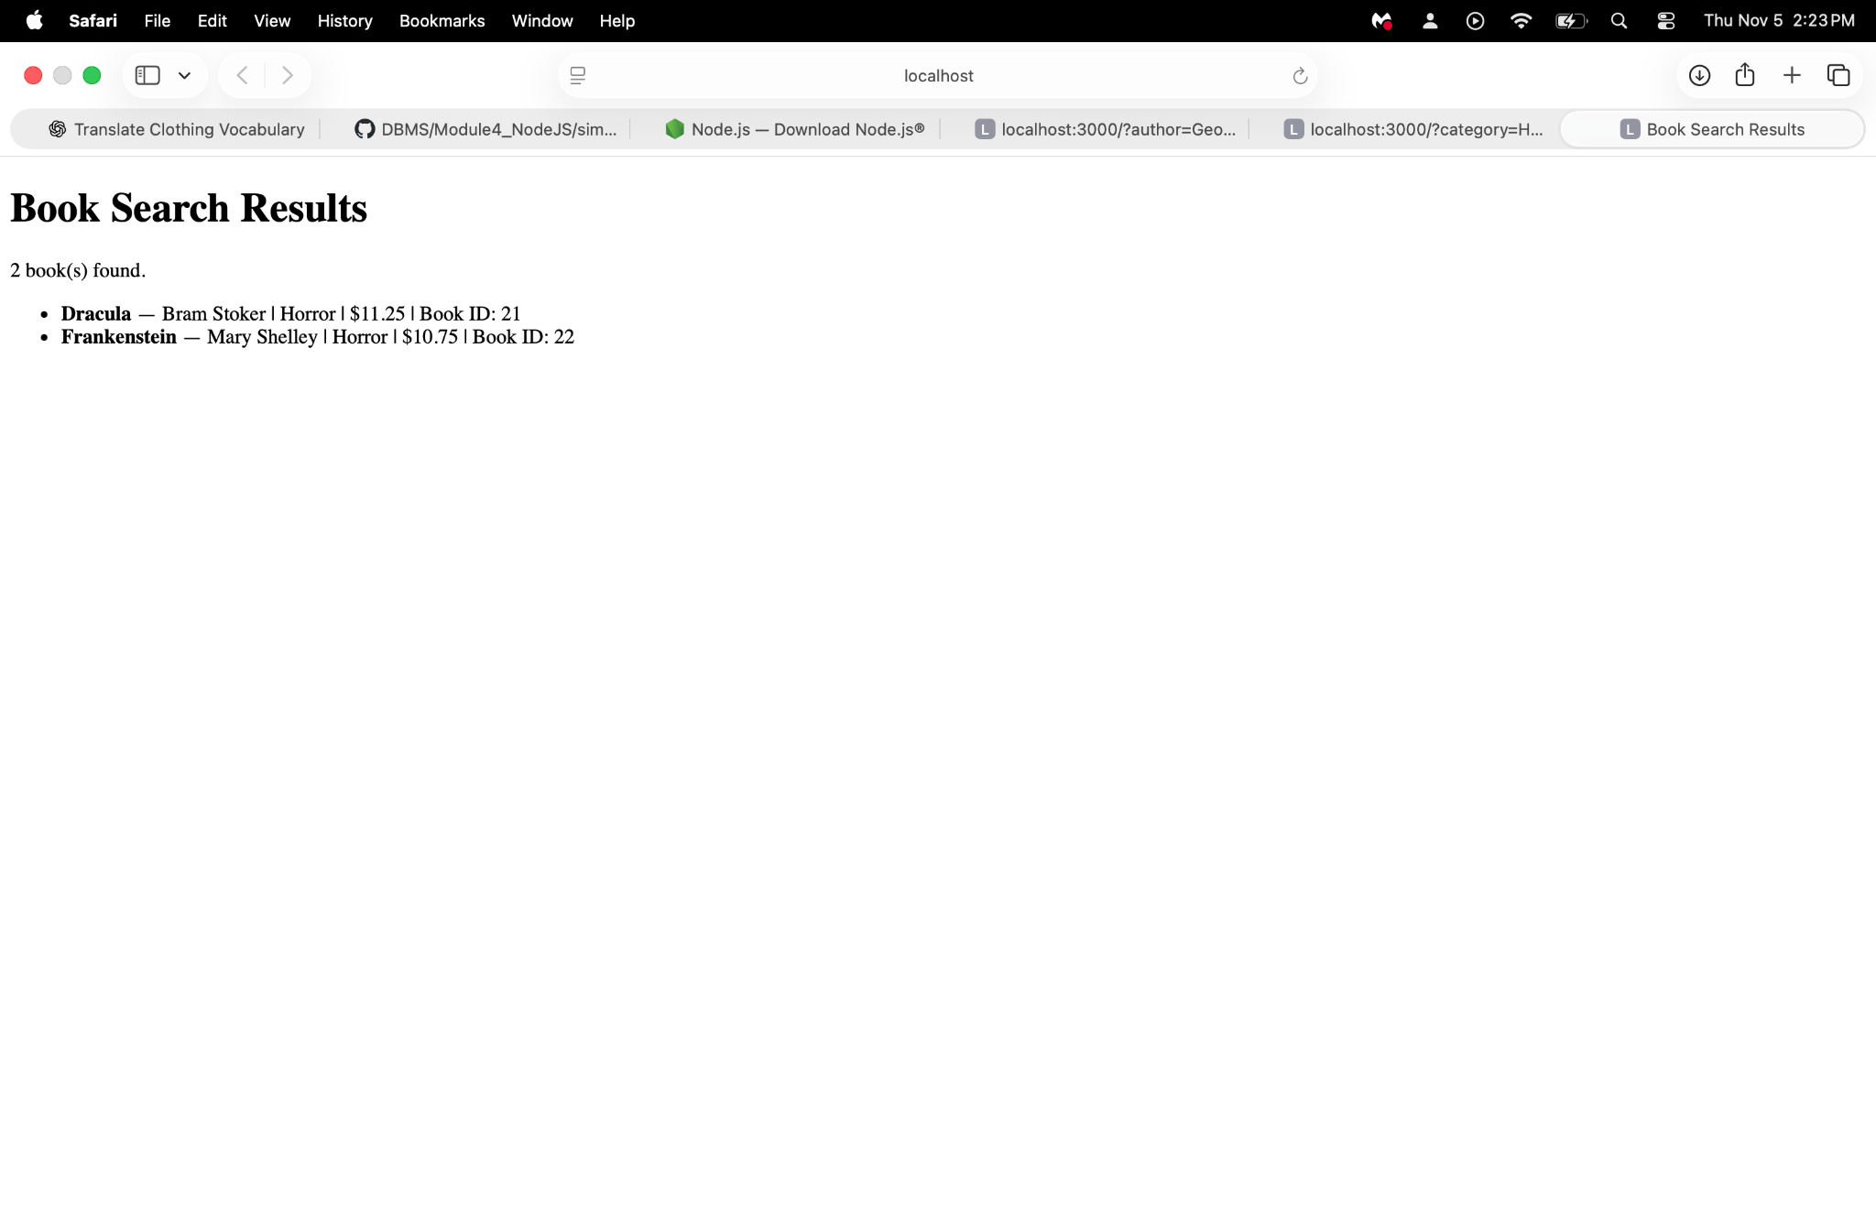
Implementation notes

The GET route at / reads category,author, and format from req.query. If both search filters are supplied, both must match. With no filter, all books are returned.

The server imports the connection pool from mysql.js and calls pool execute with placeholders and a separate values array.

JSON is the default response, format=text returns HTML with encoded text values. Database query failures return HTTP 500 with a readable error message. Invalid parameter types or formats return HTTP 400.

